PRACTICE 6

3. (\*) The file GrafoSesion6.xml contains a graph that represents a Facebook network. The vertices represent the 73 members of the network and the edges represent the friendship relations. The member v39 wants that certain information be seen by v57; for this purpose, he/she publish this information on his/her Wall and says to all his/her friends to do the same.

1. Will V57 see the information? Apply (with SWGRaphs) a suitable algorithm of Graph Theory.
2. The NSA (National Security Agency) is interested in spreading certain sensitive information to all the members of the network but, by discreetness, they want to provide it directly to as few people as possible. (Later, these people will publish the information in their walls to spread it). What is the minimum number members to whom the NSA needs to provide the information directly? Relate this number with an important concept of Graph Theory.

SOLUTION

(a)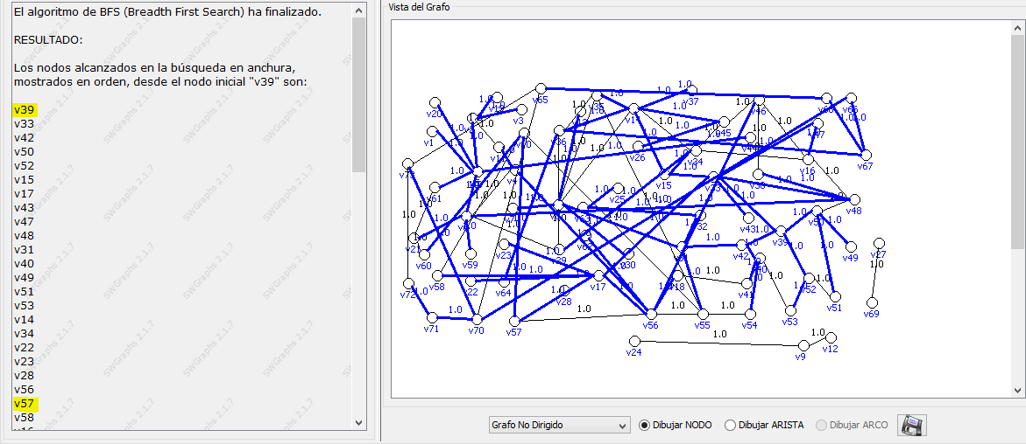

As v57 is on the list of vertices, the information will arrive.

(b) As there are three non-connected parts of the graph, the minimum number of members to provide information is three.